Copyright for test papers and marking guides remains with *West Australian Test Papers.*

Test papers may only be reproduced within the purchasing school according to the advertised Conditions of Sale.

Test papers should be withdrawn after use and stored securely in the school until 29th November 2019.



**SEMESTER TWO**

**MATHEMATICS**

**METHODS**

**UNITS 1 & 2**

**2019**

**SOLUTIONS**

**Calculator−free Solutions**

1. (a) 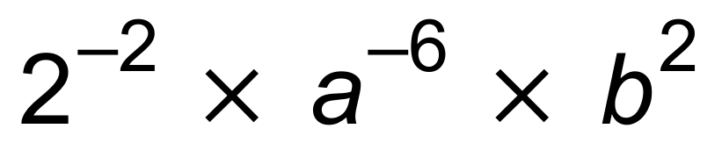 ✓

= 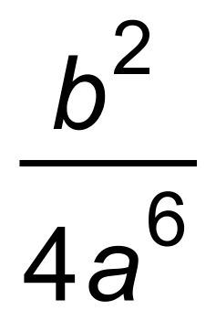 ✓

(b) 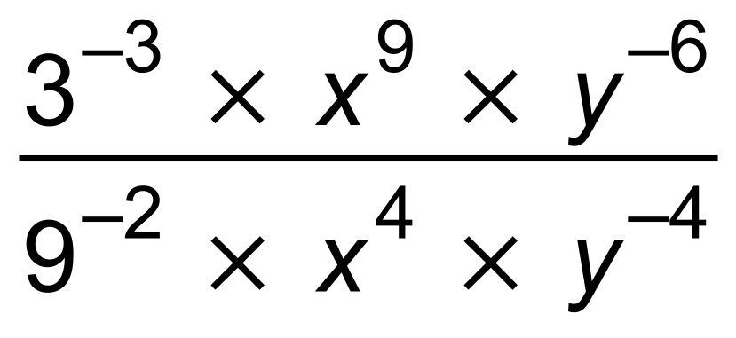 ✓

= 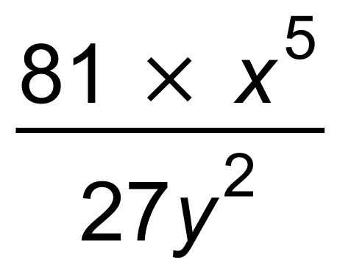 ✓

= 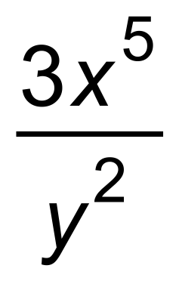 ✓ [5]

2. (a) 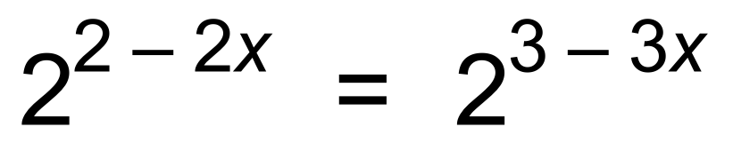 ✓

∴  ✓

(b) 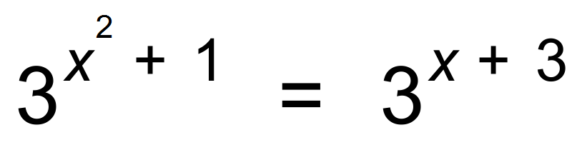 ✓

∴ 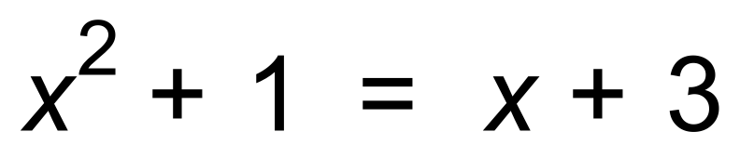 ✓

∴  ✓

∴ 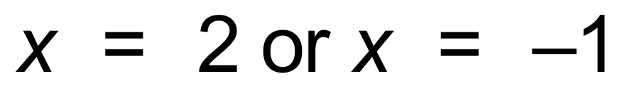 ✓ [6]

3. (a) (i) *m* = 4 ✓

(ii) 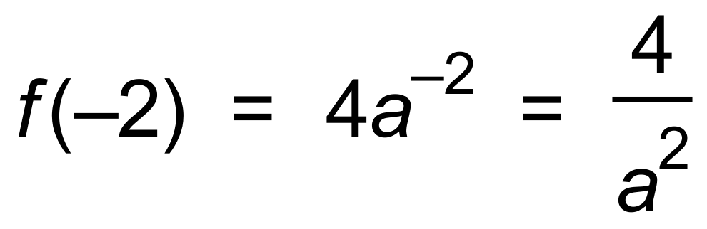 ✓

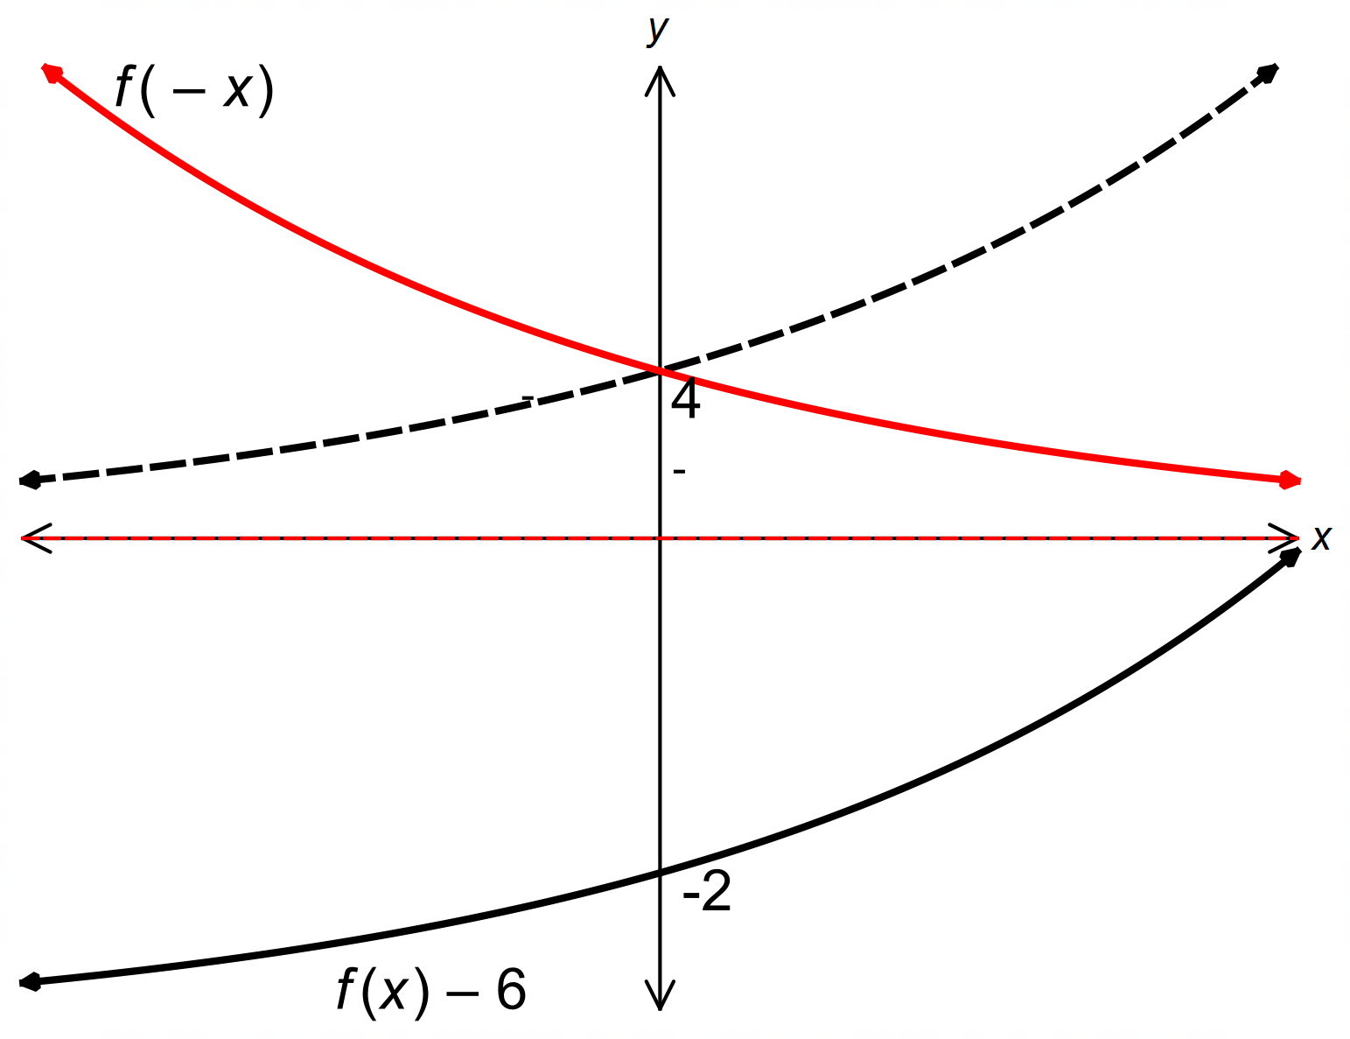 (b)

✓✓✓✓ [6]

4. (a) (i) 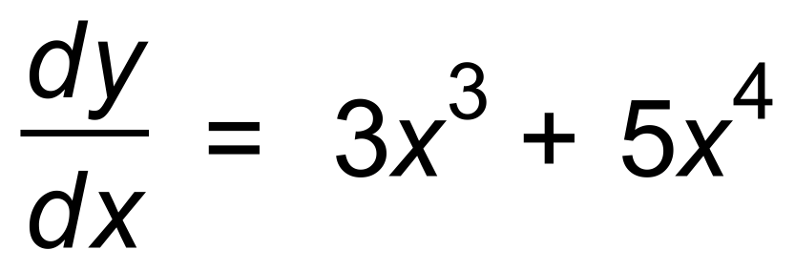 ✓✓

(ii) 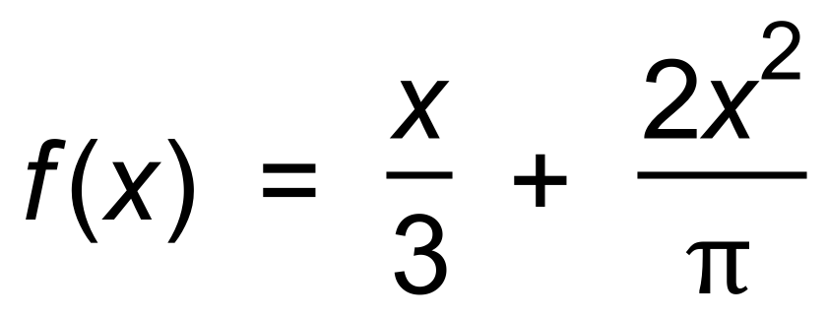

∴ 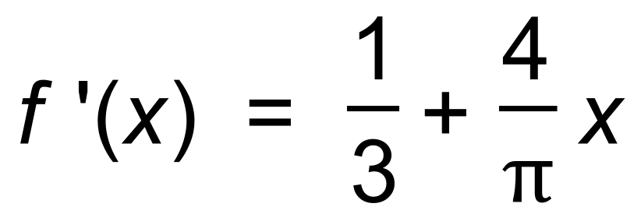 ✓✓

(b) −3*x*2 ✓ [5]

5. (a) (i) 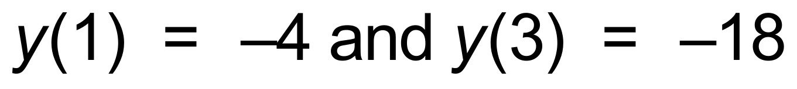 ✓

∴ 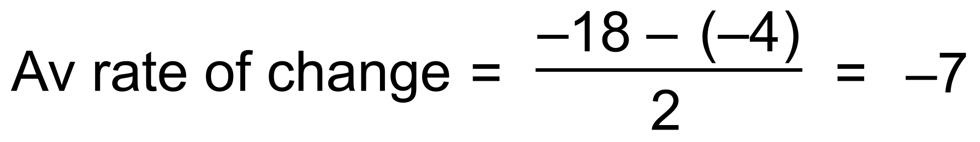 ✓

(ii) 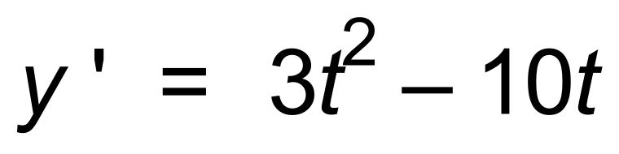 ✓

∴ 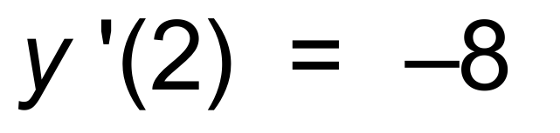 ✓

(b) 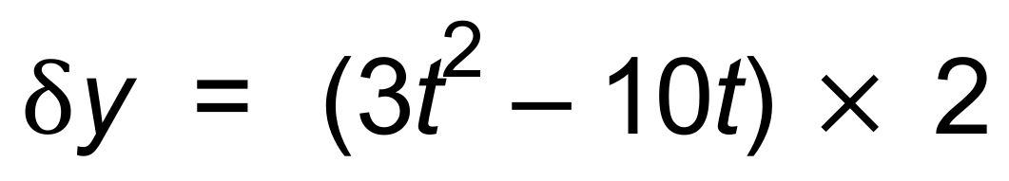 ✓

∴ 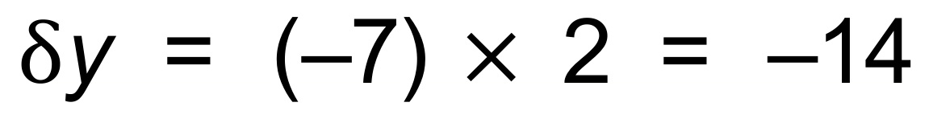 ✓

(c) 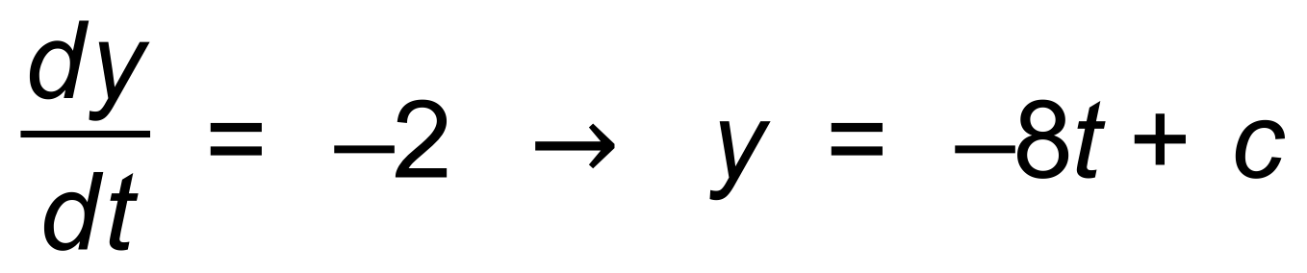 ✓

∴  ✓

∴ 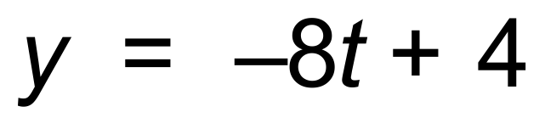 ✓ [9]

6. (a) (i) t = 1.5 ✓

(ii) t = 0.5 ✓

(b) 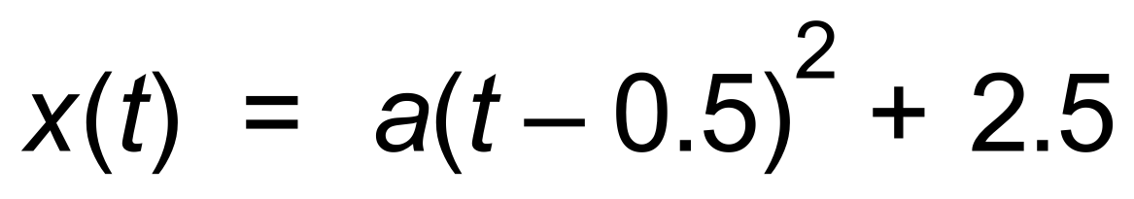 ✓



∴ 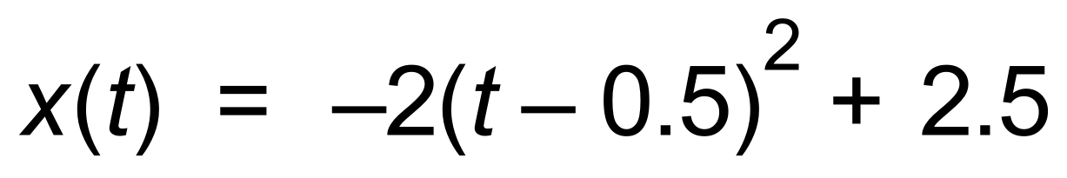 ✓ [4]

7. (a) 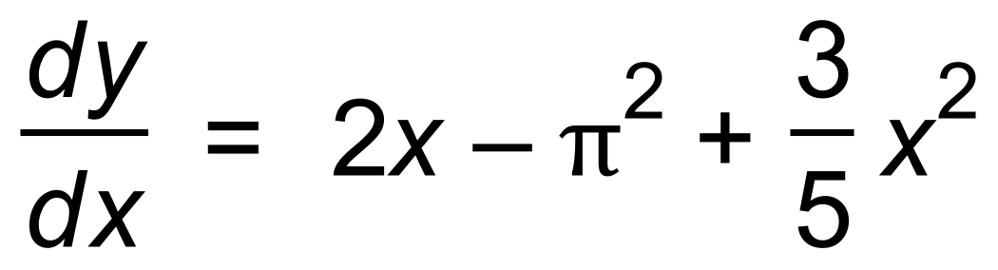

∴ 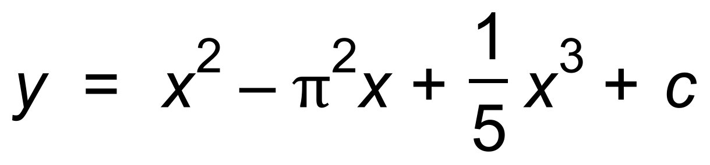 ✓✓

(b) 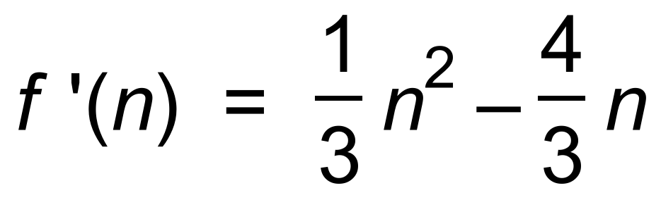 ✓

∴ 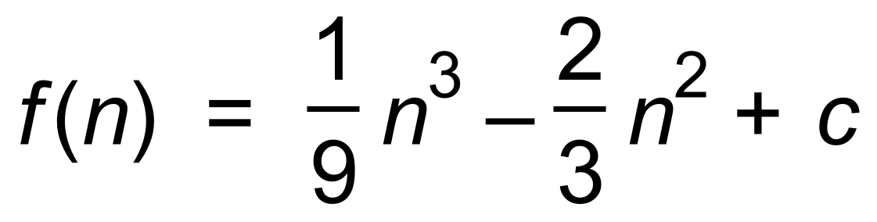 ✓✓ [5]

8. (a)  ✓

(b)  ✓

(c) 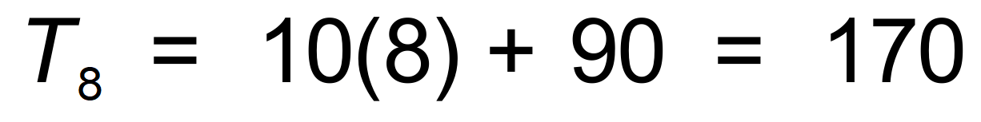 km ✓✓

(d) 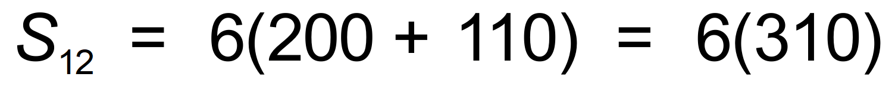 ✓

∴ = 1860 km ✓ [6]

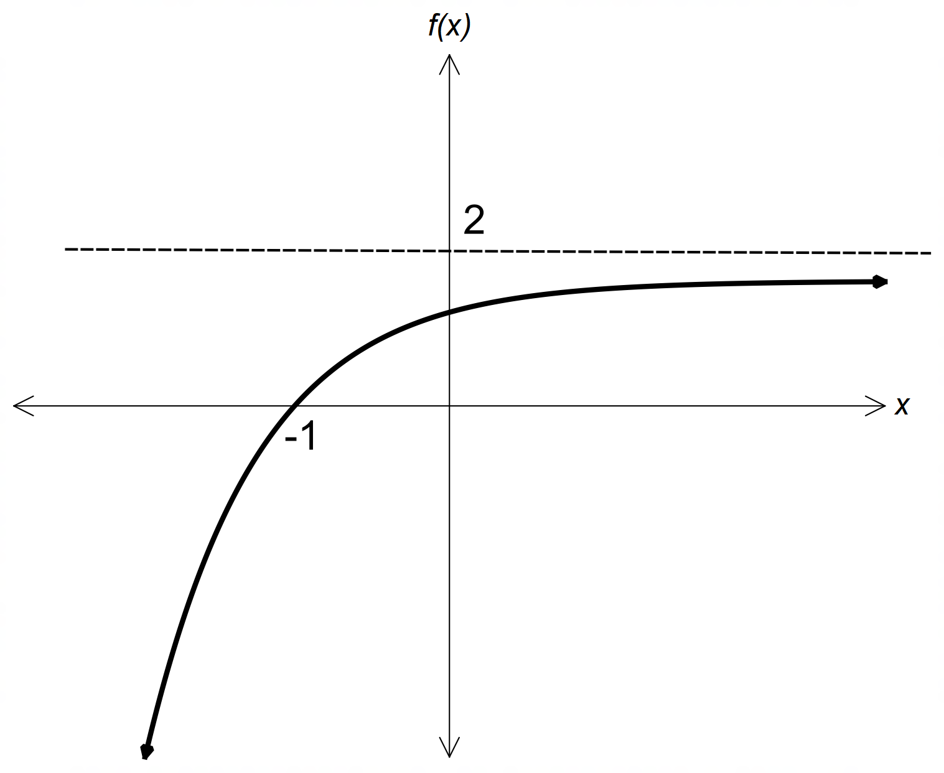9. (a)

✓✓✓

(b)

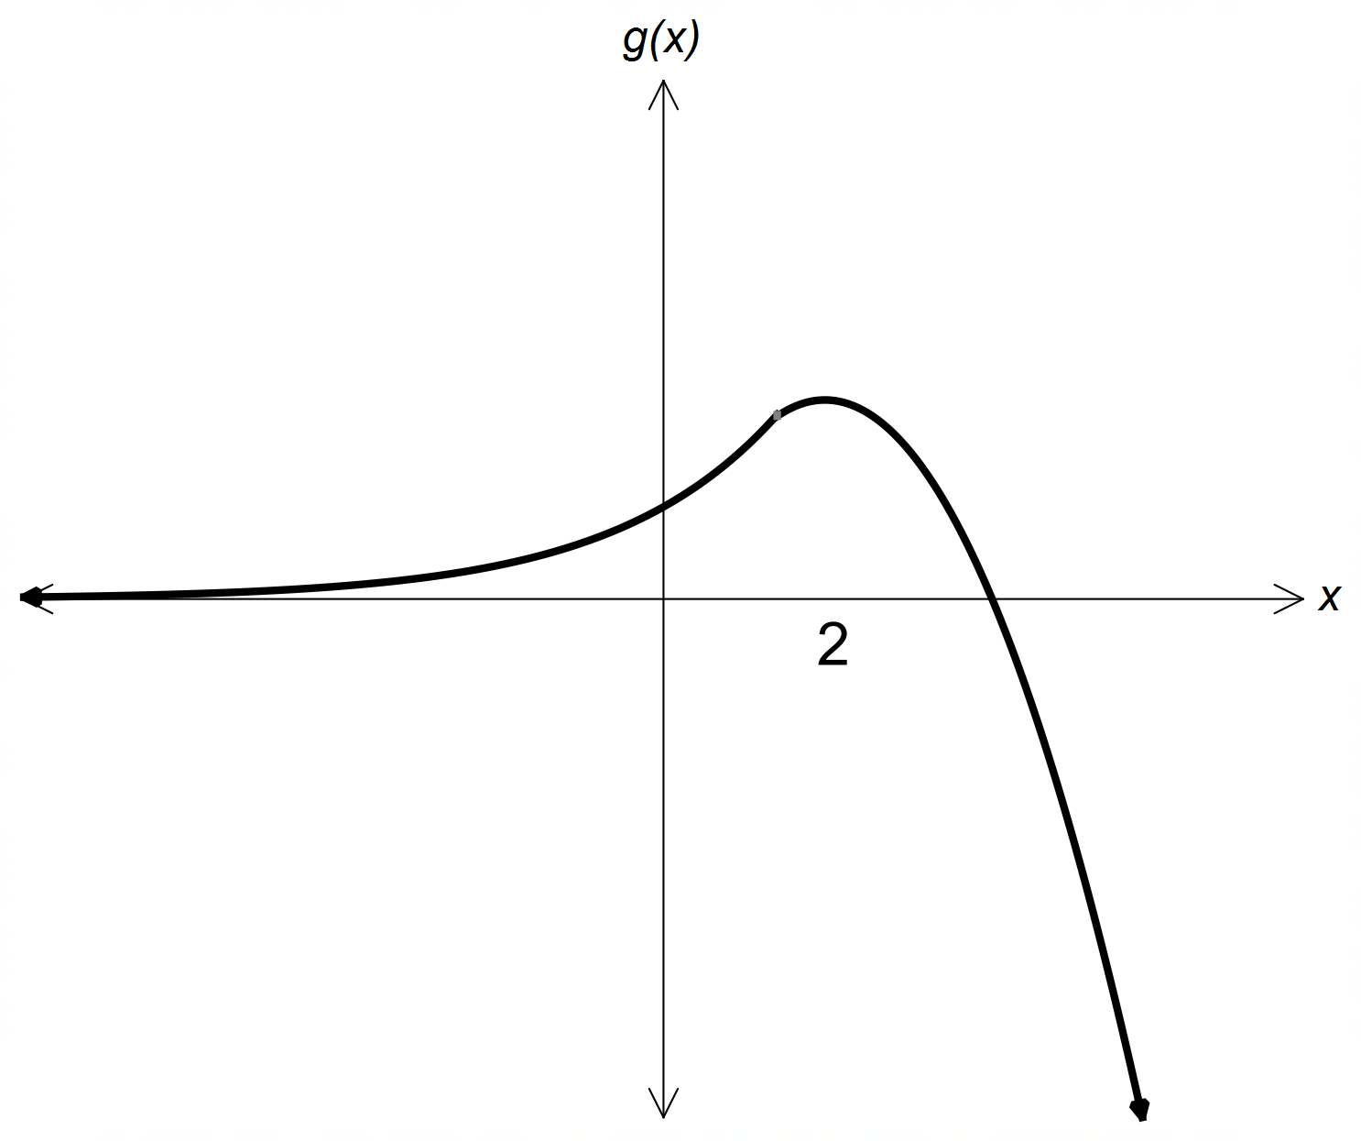

✓✓✓ [6]

**Calculator−Assumed Solutions**

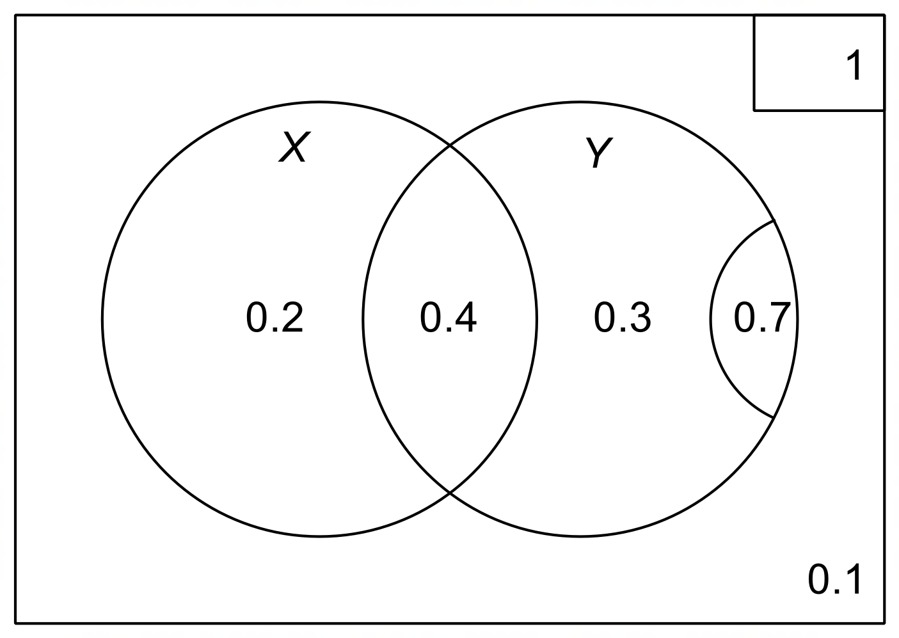10. (a)

✓✓

(b) (i) 0.6 ✓

(ii) 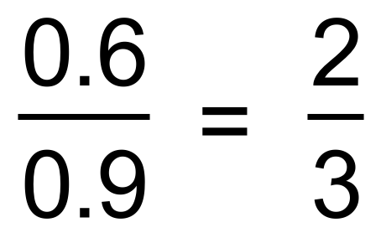 ✓✓

(c) 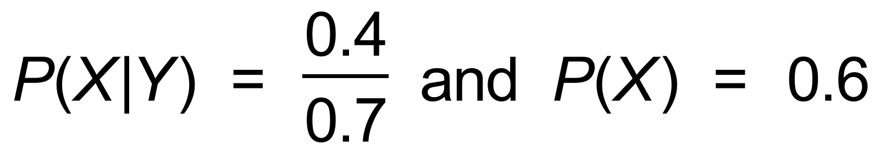 ✓

∴ not independentsince 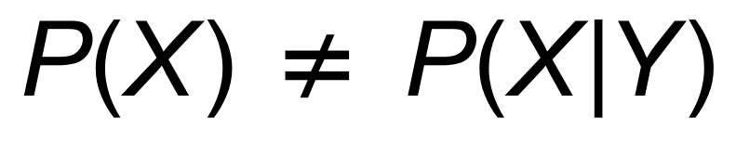 ✓

or 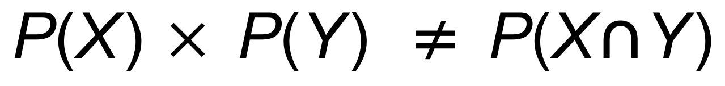 [7]

11. (a) | *r* | < 1 ✓

(b) 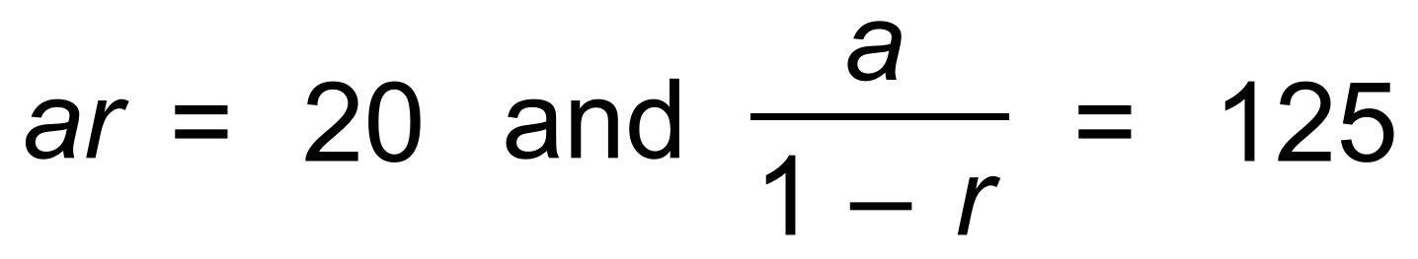 ✓

∴  ✓✓

(c) 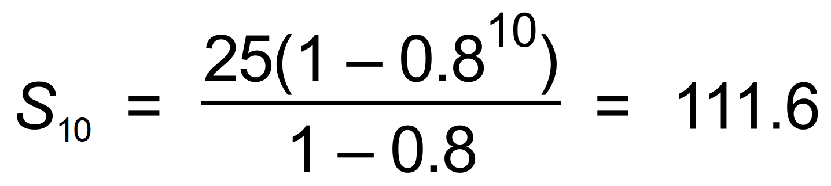 ✓

or 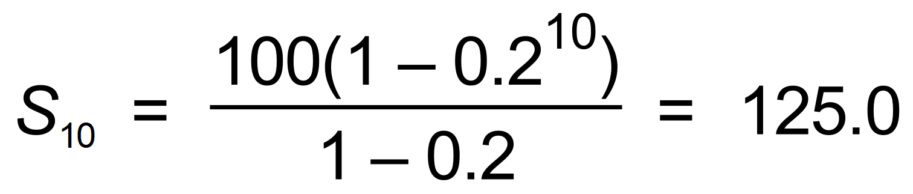 ✓ [6]

12. (a) (i) (c, 0) , (g, 0) , (k, 0) ✓✓

(ii) (e, f) , (i, j) ✓✓

(iii) (a, b) ✓

(b) a ≤ *x* < e , g < *x* < i , k < *x* ≤ m ✓✓

(c) e < *x* < g , i < *x* < k ✓✓

(d) k = 2 ✓ [10]

13. (a) 0.98 means reducing by 2% ✓

(b) 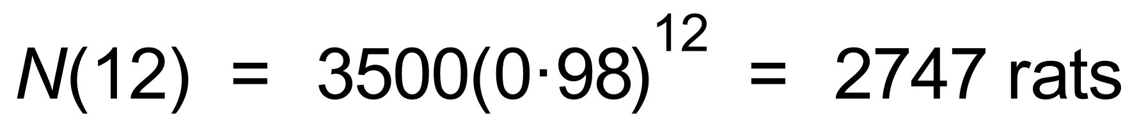 ✓✓

(c) 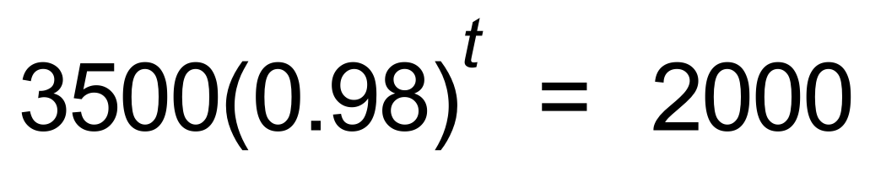 ✓

∴ *t* = 27.7 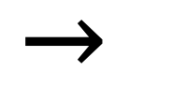 April 2021 ✓

(d) 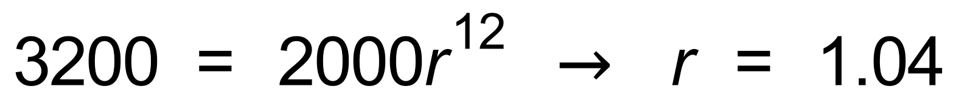 ✓

∴ 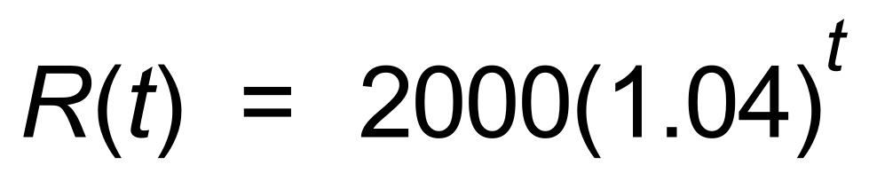 ✓

(e) 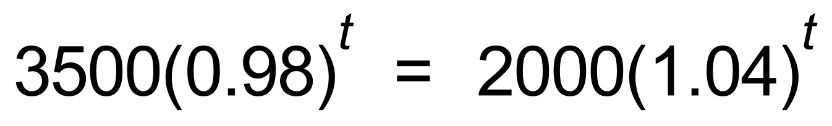 ✓✓

∴ *t* = 9.4

∴ October 2019 ✓ [10]

14. (a) 10L ✓

(b) 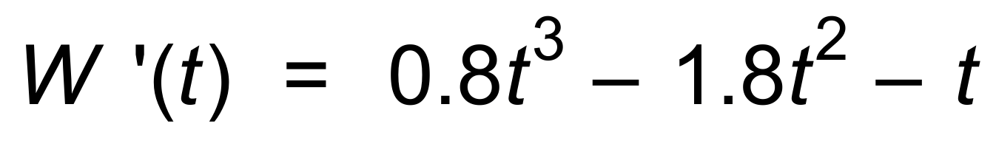 ✓

∴  ✓

∴ During the third minute. ✓

(c) (i) W(2.7) = 5.2 L ✓

(ii) W(4) = 14.8 L ✓ [6]

15. (a) (i) 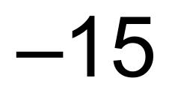m ✓

(ii) 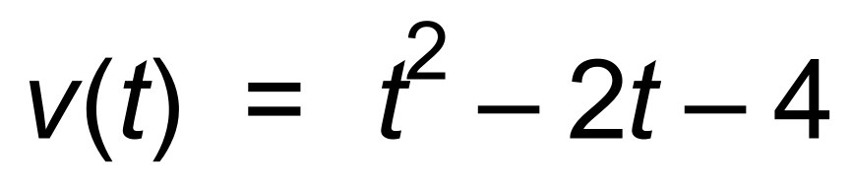 ✓✓

(b) 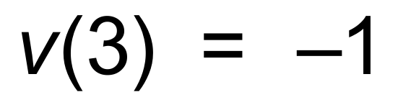 ✓

∴ Speed = 1 m/s ✓

(c) At rest when *v*(*t*) = 0

∴ 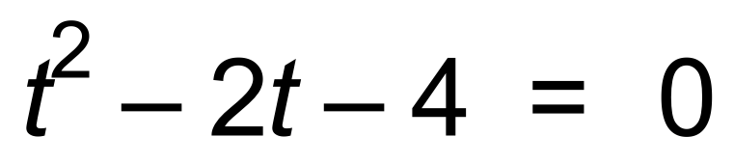 ✓

∴ *t* = 3.2 s ✓

(d) *x*(0) = −3

*x*(3.2) = −15.12 ✓

*x*(5) = −6.33 ✓

∴ Distance travelled = 12.12 + 8.79 = 20.91 m ✓ [10]

16. (a) *c* = 5 ✓

(b) 

∴ 4*a* − 2*b* = 0 ✓

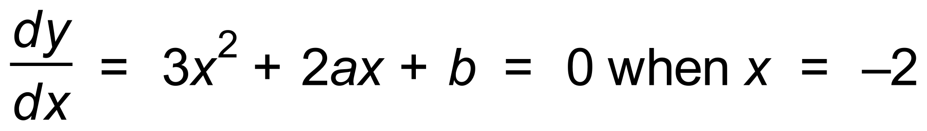

∴ 4*a* − *b* = 12 ✓

∴ *a* = 6 and *b* = 12 ✓✓

(c) 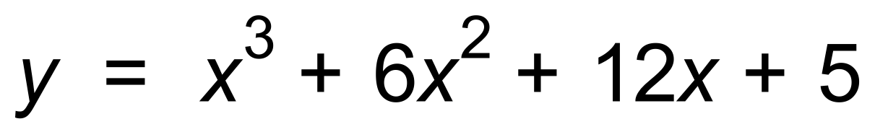

∴  ✓✓ [7]

17. (a) 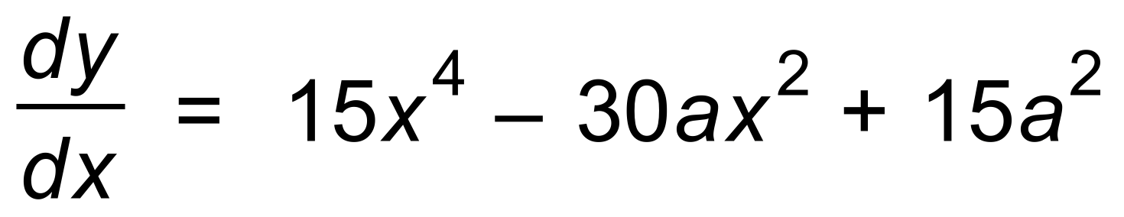

∴ 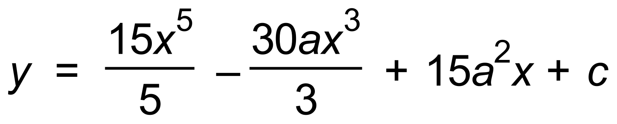 ✓✓

∴ (0, 0)  ✓

∴ 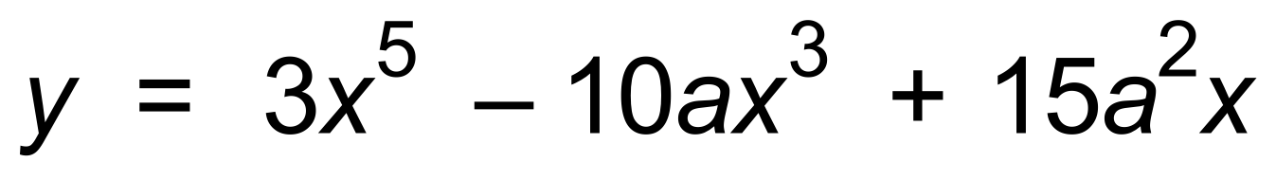

(b) 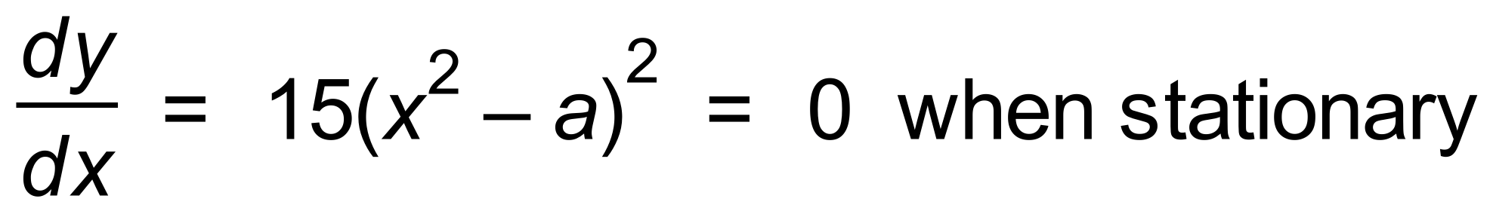 ✓

∴  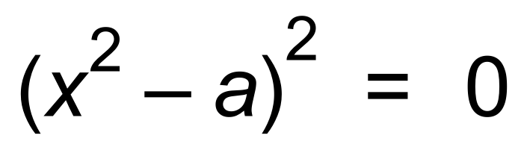

∴ 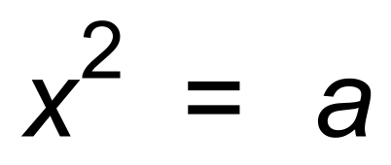 ✓

Since two stationary points *a* > 0 ✓ [6]

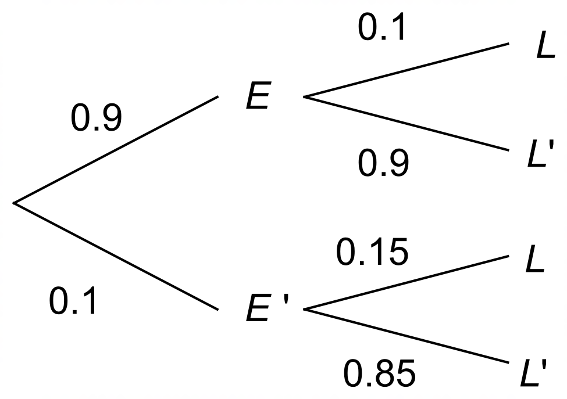18. (a)

✓✓

(b) (i) *P*(*L*) = 0.9 x 0.1 + 0.1 x 0.15 = 0.105 ✓✓

(ii) 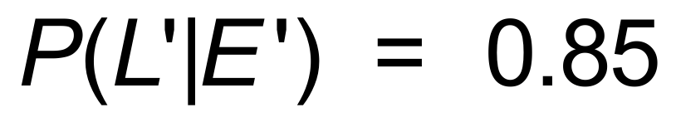 ✓

(iii) 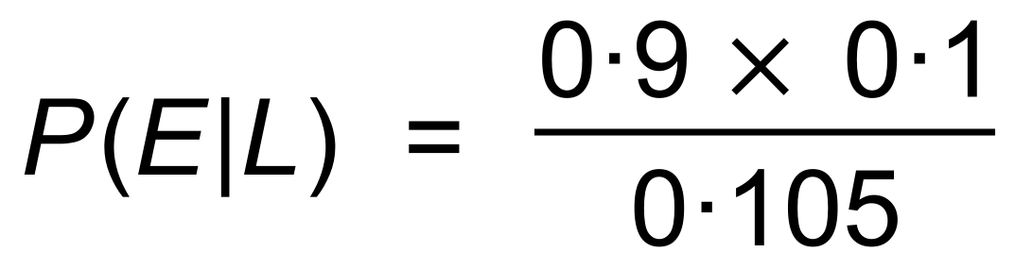 ✓

= 0.857 ✓ [7]

19. *a* = 0.5 ✓

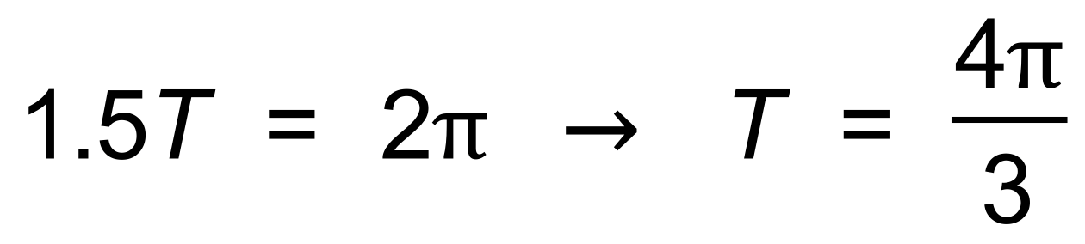 ✓

∴ 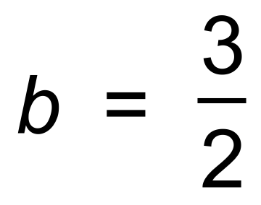 ✓

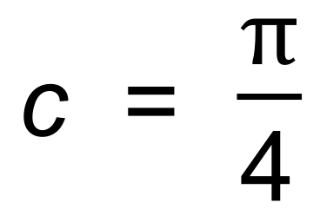 ✓

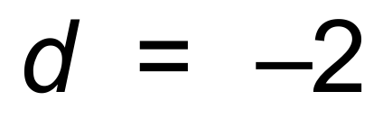 ✓

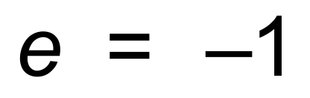 ✓ [6]

20. (a) (i) 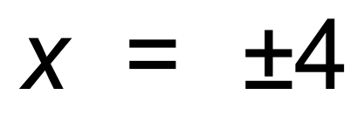 ✓

(ii) 2 ✓

(b)

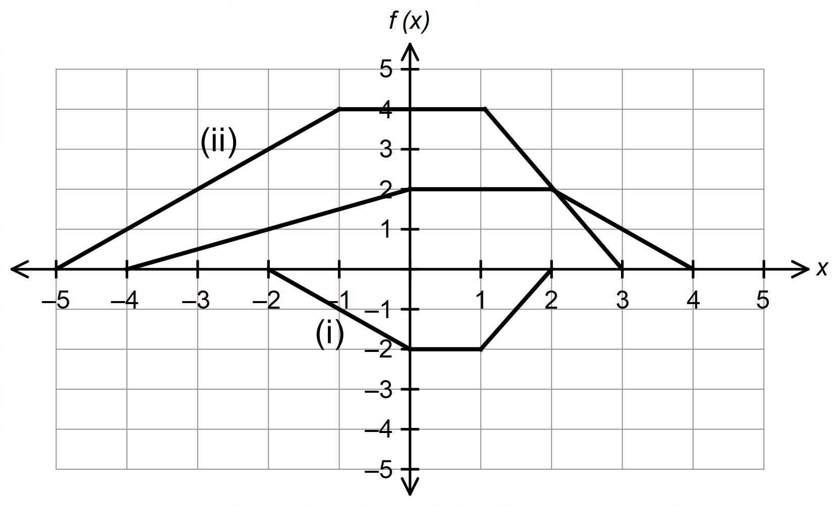

✓✓✓✓ [6]

21. (a) 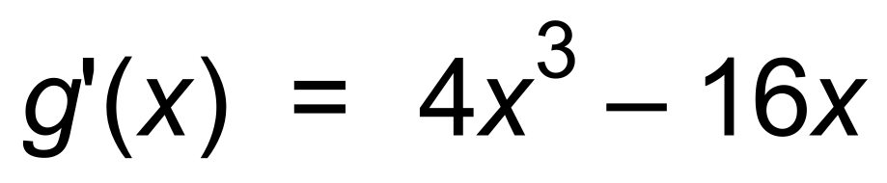 ✓

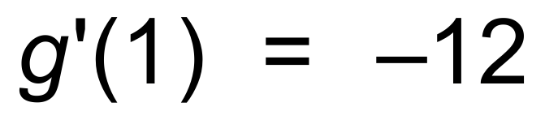 ✓

∴ *y* = −12*x* + *c*

(1, 9)  ✓

∴ *y* = −12*x +* 21 ✓

(b) (1.45, 3.61) and (−3.45, 62.4) ✓✓ [6]

22. (a) 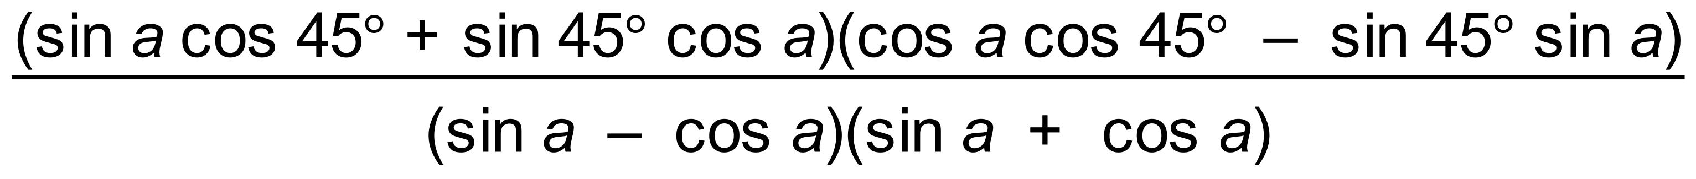 ✓

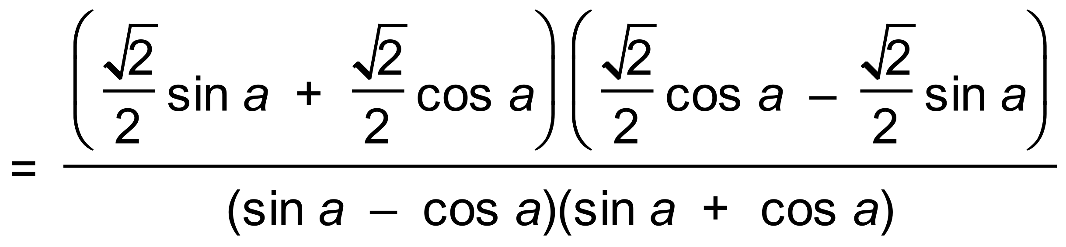 ✓

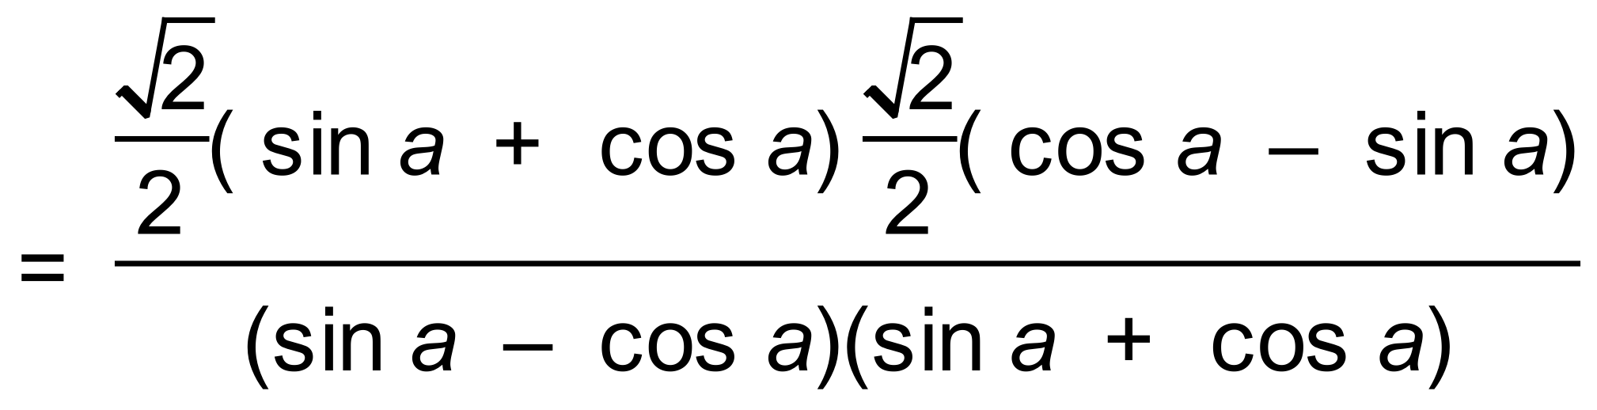 ✓

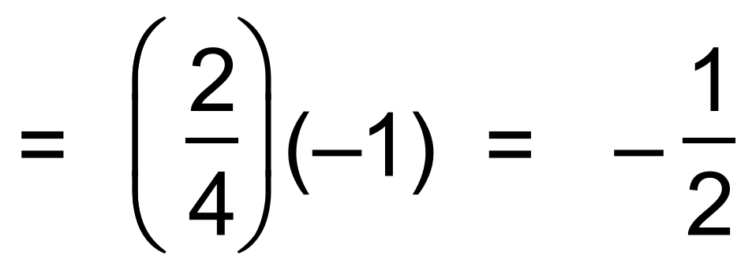 ✓

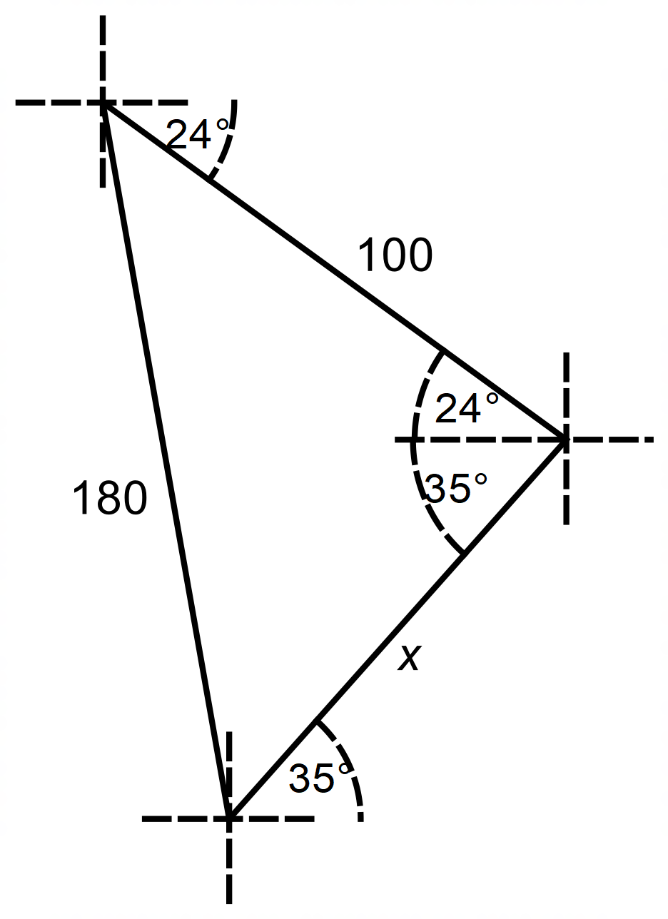 (b)

✓

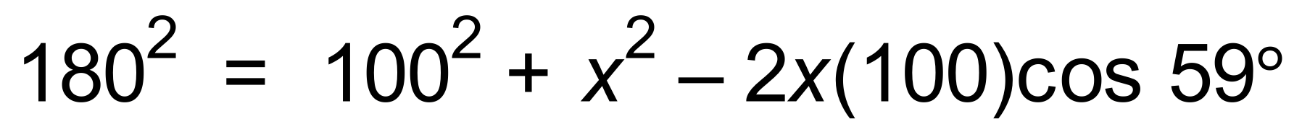 ✓✓

∴ 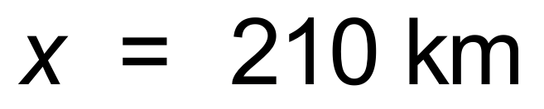 ✓ [8]

23. 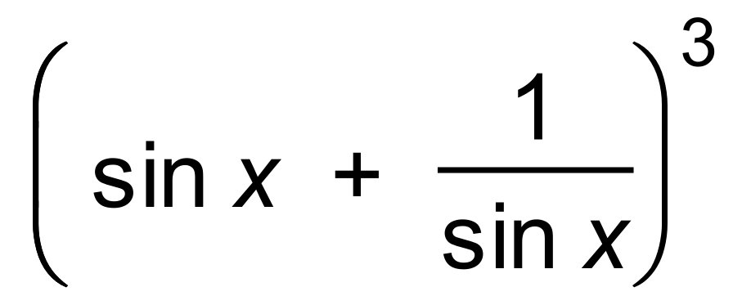

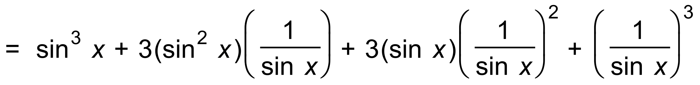 ✓✓

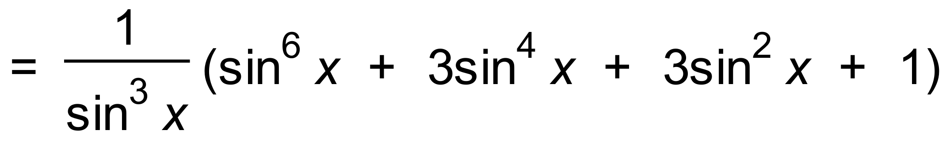 ✓ [3]